**Bed Management in a Critical Care Unit**

**J D Griffiths, V Knight, I Komenda**

**School of Mathematics**

**Cardiff University**

**UK CF24 4AG**

**Abstract**

One of the main problems facing hospital managers is in coping with the variability in demand for the services which the hospital provides. This is particularly the case in the Critical Care Unit (CCU), where inability to provide adequate facilities on demand can lead to serious consequences. Admissions to CCUs may be categorised under two headings: unplanned (emergency), and planned (elective). The length of stay (LoS) in the CCU is heavily dependent on the admission category: unplanned admissions have a much longer LoS on average than elective patients. In this paper we propose a mathematical model which shows how improvements in bed management may be achieved by distinguishing between these two categories of patients. The vast majority of previous literature in this field is concerned only with steady-state conditions, whereas in reality activities in virtually all hospital environments are very much time-dependent. This paper goes some way to addressing this problem.

***Keywords:***Queueing theory, Bed occupancy, Critical Care, Time-dependency

1. **Introduction**

Hospital managers have the unenviable task of ensuring that demand for hospital services of various types can be adequately provided. In some cases, failure to provide a service may just cause inconvenience to a patient, but in other cases delay to admission may be life-threatening. The latter possibility is particularly relevant in Critical Care Units (CCU). Nowadays, most hospitals provide CCU facilities which are a combination of at least two levels of care; basic intensive care facilities for patients whose conditions merit extra care with nurse provision on a 1:1 basis, and high dependency care for patients whose needs are accommodated by nursing on a 1:2 basis. Nurses working in CCU are specially trained, and are typically in short supply.

This study was undertaken at a large teaching hospital, the University Hospital of Wales at Cardiff (UHW). The CCU has 24 beds, with a further 5 beds available in storage for emergency use. The cost of care, mostly staffing costs, is about £1800 per bed-day, whilst the additional cost of the specialised equipment at each bed-side is around £60,000.

One of the main difficulties which the director of the CCU faces lies in the unpredictability of the number of beds which will be occupied on any particular day.

Figure 1 shows the large degree of variation in daily bed occupancy over a five year period. As will be noted, daily occupancy can be as low as 7, and as high as 30. This high degree of variability has many important implications. For example:

1. If all beds are occupied when an emergency admission occurs, then that

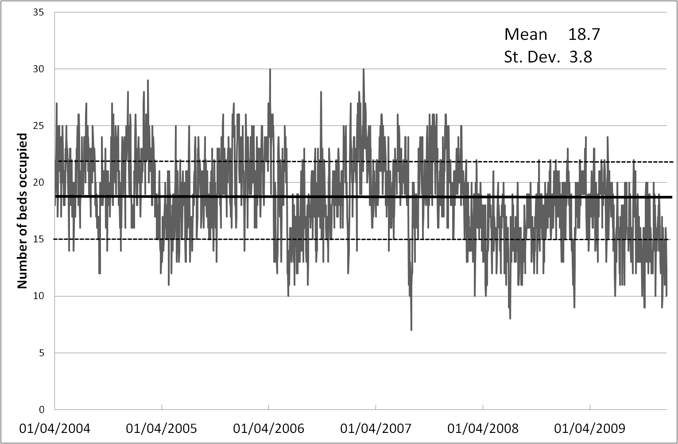

Figure 1: Daily bed occupancy in the CriticalCare Unit at the University Hospital of Wales at Cardiff from 2004 -2009.

patient’s condition may worsen while action is taken to find a bed, possibly in another hospital some distance away.

(ii) If the number of nurses employed on a particular shift is less than that needed, then agency nurses have to be employed at a cost of about three times that of the hospital nurses.

The project described in this paper had several aims:

1. To suggest measures which may be implemented to increase the throughput of patients in the CCU.
2. To determine ways in which the degree of variation in daily bed occupancy

may be reduced.

(iii) To investigate whether it is possible to predict levels of bed occupancy for the

next few days, given the present occupancy.

(iv) To produce recommendations relating to nursing levels, so as to optimise

staffing costs.

In answering these aims, much use has been made in this paper of a queueing theory approach, and hence a brief review of relevant queueing theory literature is appropriate.

Much of the initial work on queuing theory is attributed to A K Erlang (1909), whose work on analysing waiting times for call connections on the Copenhagen telephone system is regarded as seminal. However, the use of queueing theory in a healthcare setting was little used until the pioneering work of Bailey (1952) appeared. In this paper queueing theory was used to develop an out-patient clinic scheduling system that gave acceptable results for patients (in terms of waiting time) and staff (in terms of utilisation). Homogeneity of patients was assumed as far as their service time distributions were concerned, and also it was assumed that all patients arrived for appointments on time. Over more recent years a vast number of queueing models have been developed for use in healthcare settings. Good reviews of queueing theory applied to healthcare are available in Creemers and Lambrecht (2008) and Fomundam and Herrmann (2007), and an excellent account of a wider set of queueing results may be found in Gross and Harris (1998).

Simulation approaches that allow for a greater level of detail have also been used to plan capacity so as to minimise the consequences of inadequate resource availability. Capacity planning cannot be based simply on averages of numbers of admissions and lengths of stay, as this may underestimate the number of beds required Costa *et al* (2003). Simulation and queueing theory models were utilised by Kim *et al* (1999) to describe activities in an Intensive Care Unit (ICU) based in Hong Kong. In Ohio at the Cincinnati VA medical Centre, Cahill and Render (1999) built a model in which they tested several alternative bed configurations to see whether high bed-occupancy level (81%) could be reduced to more acceptable levels. In the Netherlands, Litvak *et al* (2008) constructed models of several CCUs in a region, and tested the scenario of reserving a pooled number of beds across the region for emergency admissions. Various ‘what-if’ scenarios relating to CCU nurse numbers have been investigated by Griffiths *et al* (2005 a) to find the optimal nursing requirements. CART analysis has also been widely used in modelling CCUs, Shahani *et al* (2008). Many simulation models exist to help manage bed capacities not only in CCUs, but in whole hospitals Harper and Shahani (2002).

This approach is advantageous in that patients are in essence modelled as agents and may possess characteristics, such as ‘source of admission’, ‘type of surgery’ or ‘age’, which influence their progress through the system. In addition simulation approaches generally have advantages in the presentation of models to decision makers (through graphical interfaces). Despite the ever increasing computational power available, simulation approaches can nevertheless prove time consuming, due to the large number of runs needed to obtain results to an acceptable degree of accuracy.

The approach presented in this paper is thus to use a queuing theory model as in the works of Harper (2002); Gorunescu *et al* (2002); Cooper & Corcoran (1974); Fackrell (2009), Griffiths (2005 b)). The paper by Au *et al* (2009) used an Erlang loss model in an emergency department to estimate the probability of reaching capacity in a specified time, given the current occupancy, for different times of the week. A queueing model may be described by three principal components: the arrival distribution, the service distribution and the number of service channels Kendall (1953). Applying this principle to the CCU environment, these correspond to the patient’s inter-arrival time distribution, the distribution of their length of stay in the unit, and the number of available staffed beds.

Importantly, the vast majority of approaches in the literature assume steady state conditions for the system in question. Most uses of time dependent queueing theory related to healthcare systems are concerned with the staffing of emergency units, Green *et al* (2001, 1991, 2006). Various approaches have been used to give the smallest number of servers needed (for each time period) to ensure a given performance standard. For a review the readers are encouraged to see Ingolfsson *et al* (2007). Existing methods use an amalgamation of steady state models, Green *et al* (2001, 1991), whilst other methods are based on the ‘offered load’ of a system (the number of patients present in the equivalent M(t)/M/∞ queue, Jennings *et al* (1996)). In Ingolfsson *et al* (2007) various approximations are tested and compared to what is referred to as the ‘exact’ method, where the Chapman-Kolmogorov equations are solved numerically. The approach proposed in this paper will build on these methodologies by obtaining time dependent occupancy probabilities for an intensive care unit; numerical results are available for a wide range of parameter values.

1. **Data**

We are indebted to the staff of UHW for providing us with the large datasets that made our analysis possible, and for the high degree of accuracy of the data contained therein. The datasets gave detailed information on over 8,000 patients during the period April 2004 – December 2009.

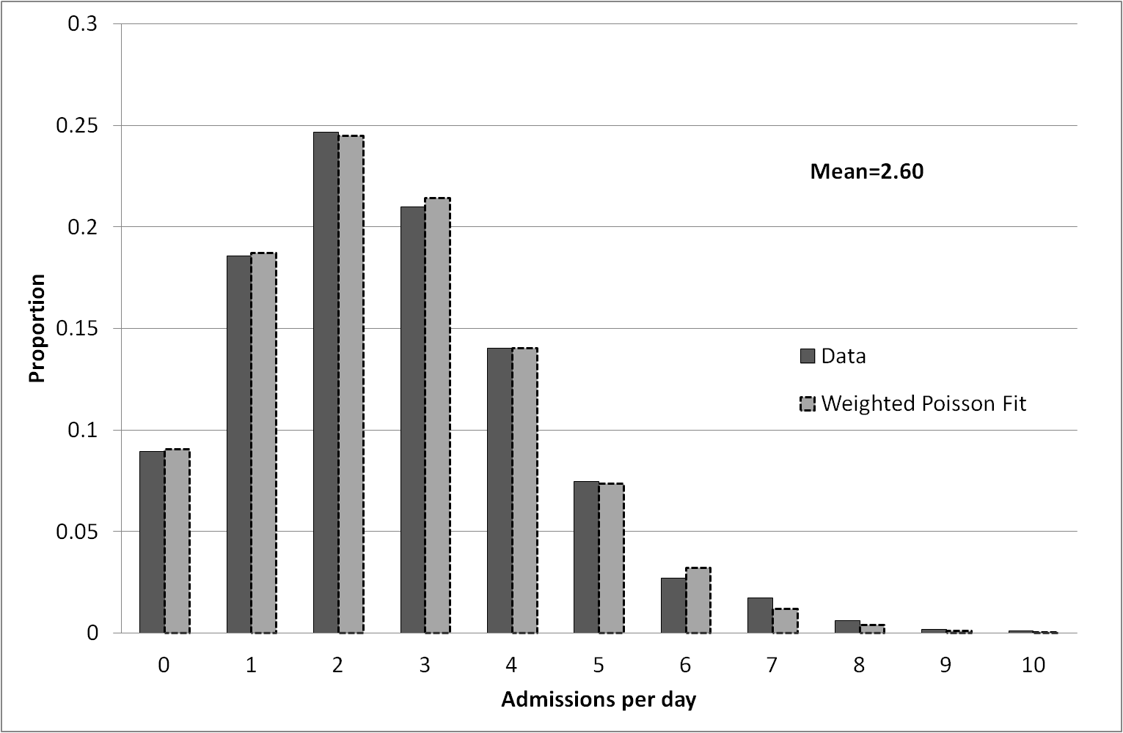

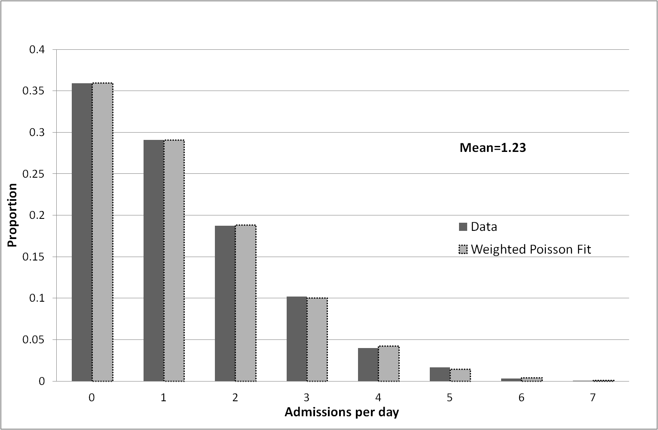

Figure 2 Distribution of daily admissions to CCU for emergency (upper diagram) and elective (lower diagram) patients

As was mentioned earlier, we need to consider emergency and elective patients as separate and independent admission streams. Figure 2 shows the distribution of the numbers of admissions in each of these categories. After extensive investigation, it was found possible to determine excellent fits to the data using a weighted Poisson distribution: $$P\left(n\right)=ω\frac{e^{{-λ}_{1}}λ_{1}^{n}}{n!}+(1-ω)\frac{e^{{-λ}_{2}}λ_{2}^{n}}{n!}$$

with parameters $ω=0.019 λ_{1}=0.01 λ_{2}=2.62$ (upper diagram) and $ω=0.356 λ_{1}=0.378 λ_{2}=1.72$ (lower diagram). It should be noted that the rate of admissions for emergency patients is approximately twice that of elective patients. If we look at these two categories in a little more detail on a ‘day of the week’ basis, we find (not unexpectedly) that there are far fewer elective admission on the weekend, see Figure 3. Further, we note that emergency admissions have a fairly constant arrival rate, irrespective of the day of the week. To a large extent, it is not possible to exercise any degree of control over the arrival rate of emergency patients – accidents are no respecters of days of the week. The main control that the director of a CCU has lies in deciding whether or not a CCU bed will be available for an elective patient following surgery. If bed availability cannot be guaranteed, then that patient’s surgery will be cancelled, leading to disruption of operating theatre schedules, and promoting high levels of stress for patients, relatives, and staff.

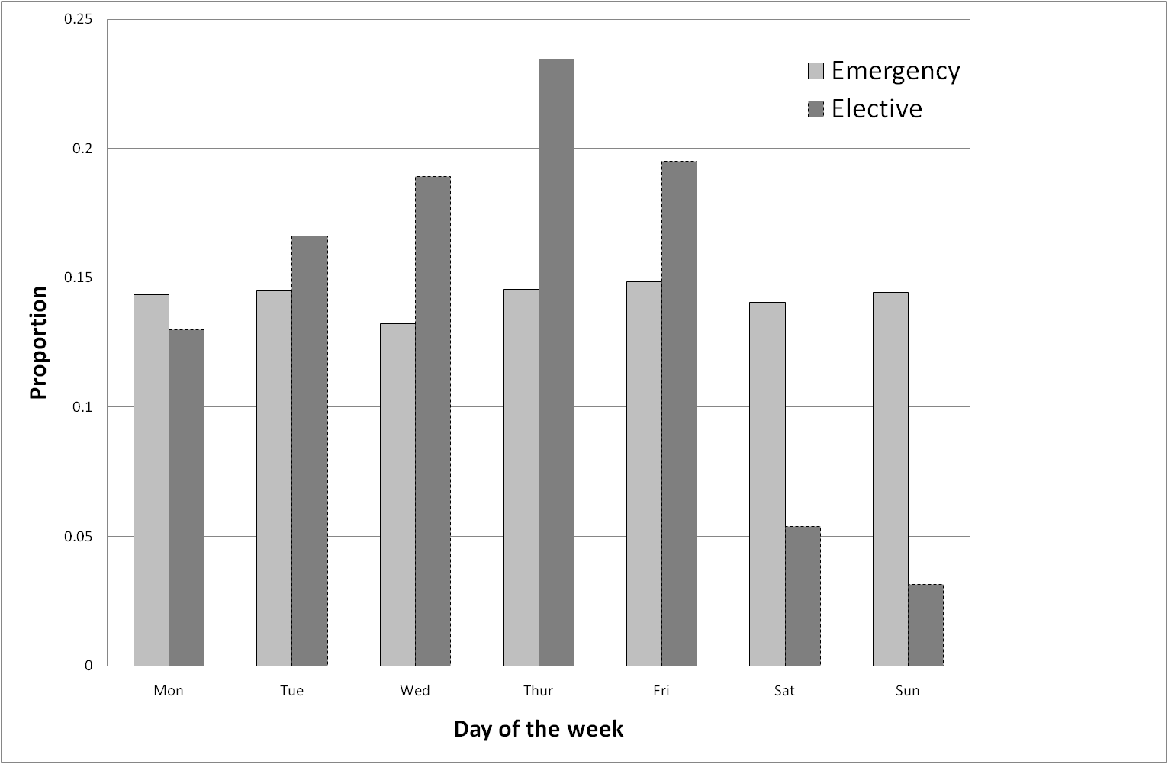

Figure 3 Emergency and elective patient admissions by day of the week

Turning now to length of stay (LoS) for the two categories of patients. Figure 4 shows that LoS for emergency patients is considerably greater than that for elective patients. Also shown is the fit to the LoS data by means of weighted Negative Exponential distributions: $$P\left(a<x=LoS<b\right)=\int_{a}^{b}{\left(ω λ_{1}e^{{-λ}_{1}x}+(1-ω)λ_{2}e^{{-λ}_{2}x}\right)dx}$$

with parameters $ω=0.311 μ_{1}=0.089 μ_{2}=0.326$ (upper diagram) and $ω=0.424 μ_{1}=0.235 μ_{2}=1.402$ (lower diagram). Again, excellent fits were found.

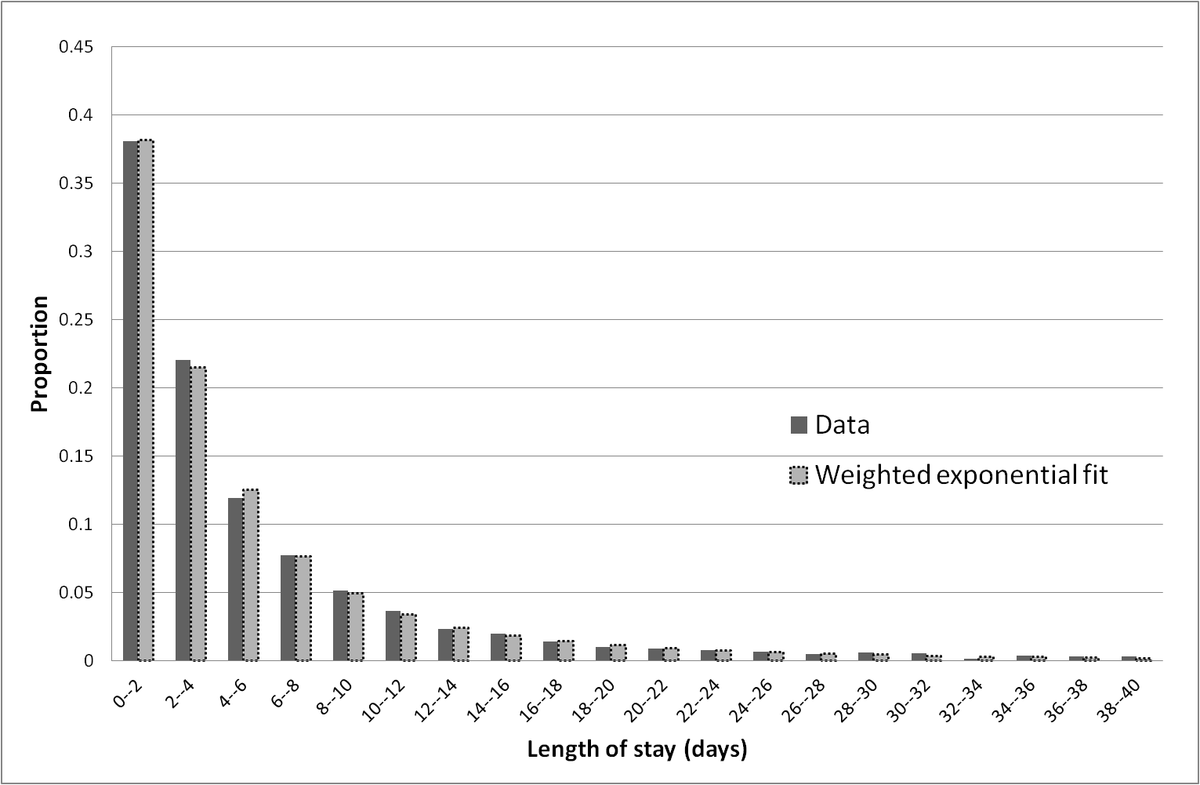

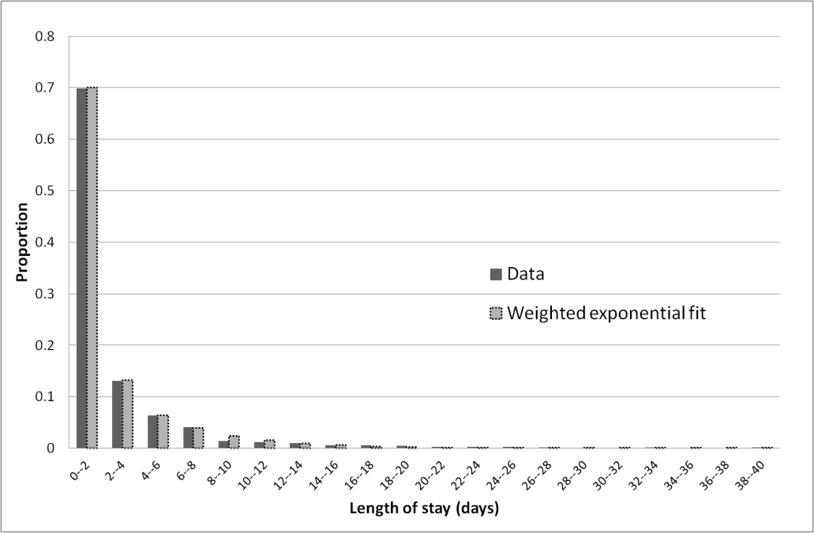

Figure 4 Distribution of length of stay for emergency patients (upper diagram) and for elective patients (lower diagram)

1. **Mathematical Model**

From the previous discussion, it is clear that any mathematical model must cater for the two categories of patient, both with regard to their admission rate and to their length of stay. Further, the hospital states that it never permits a queue to occur for admission to CCU. At first sight, this appears to be an unlikely scenario, but the data justifies this claim. The explanation is that to avoid a queue forming they would either temporarily cancel elective admissions, or make attempts to divert a potential admission elsewhere, or create what they call a ‘virtual bed’, basically a trolley bed possibly located outside the CCU environment. With these matters in mind, we propose initially a simple service model with no queueing allowed.

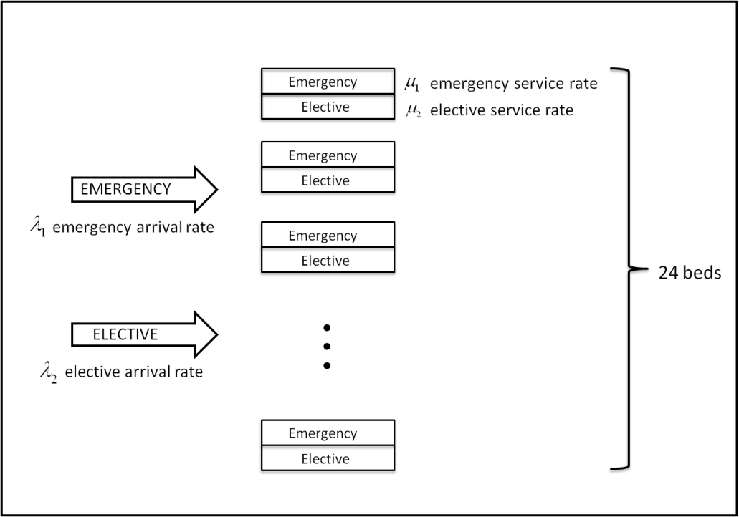

Figure 5 The queueing model

Figure 5 illustrates the system. Emergency and elective patients arrive according to a Poisson process with rates  and  respectively. The lengths of stay for emergency and elective patients are distributed according to an exponential distribution with mean waiting times  and , respectively. There are 24 beds (service channels) available, and no queues are allowed to form. The objective at this stage is to determine how daily bed occupancy varies, and to investigate how that occupancy is distributed amongst emergency and elective patients.

Let denote the probability that *i* emergency and *j* elective beds are occupied at time *t*. As there are 24 beds available, this leads to 325 possible states of the system. Let  be the probability that *n* beds are occupied at time *t*. Thus,  for .

It is a comparatively straightforward exercise to set up differential-difference equations to describe the system. There are 7 sub-categories covering the 325 equations, Table 1.

For the present we will be concerned with the steady-state solution of these equations; we will return to the time-dependent aspect later. denotes the steady-state probability corresponding to 

The steady state equations may be written in the form shown in Table 2.

|  |  |
| --- | --- |
| For |  |
| For |  |
| For |  |
| For |  |
| For |  |
| For |  |
| For |  |

Table 1 The differential-difference equations



Table 2 The steady state equations

These equations may now be solved by back-substitution. The results are:

 ,

where .

The expression for looks similar to the terms of a binomial expression, and by multiplying numerator and denominator by *i!*, we can achieve the clearer result:

 (1)

 may be determined from equating the summation over all possible probability states to unity.

We have thus derived an expression for the joint distribution of the number of emergency and elective beds occupied in steady state conditions. Later, we will discuss the application of this important result.

We note that for fixed values of *i*, the terms are just the individual terms of the binomial expansion of , and so the sum of these terms over *j = 0,1,..,i* will give . This immediately gives us a very compact formula for , the steady-state probability of the number of beds occupied, irrespective of whether the occupants are emergency or elective patients.

 (2)

can be determined in the usual way from 

We note that the result (2) is in fact Erlang’s loss formula for the queue M/M/c/c, see Gross and Harris (1998).

Figure 6 shows close agreement in overall bed occupancy levels when comparing the result (2) with the corresponding relevant data.

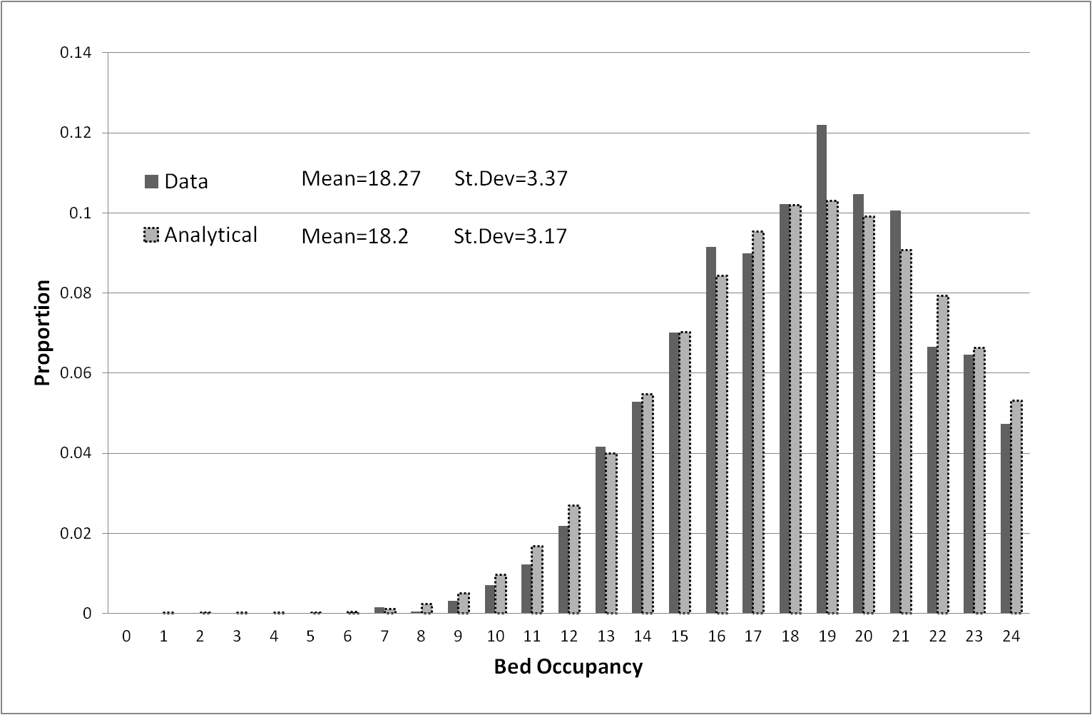

Figure 6 Comparison between data and analytic results for bed occupancy

We may proceed further with this connection between the M/M/c/c queue and the result (1). Given that the two arrival processes (elective and emergency) are independent Poisson processes, we may combine these into a single input. We now see that we can also combine the two service rates into a single service rate. The mean service time is  with probability , and with probability . Thus, the mean service rate is given by

 (3)

The expression  is therefore identical to . This means that if we are interested only in the number of beds occupied, irrespective of whether a bed is occupied by an emergency or elective patient, we may use the results of M/M/c/c, with equation (3) providing the overall service rate.

1. **Scenario Analysis**

We now consider the implications of changes in the mode of operation of the CCU. Recall that the main method of control over the rate of admissions to the CCU is by means of changing the admission rates of elective patients. Two of the principal aims of this study are to increase the throughput of patients admitted to the unit, and to reduce the variation in bed occupancy levels on a day-to-day basis, so that more stability may be observed in the numbers of nurses needed per shift.

Figure 6 illustrates the degree of variation apparent in the daily bed occupancy. The mean number of beds occupied over the five-year data period was 18.3 per day, and the standard deviation was 3.37. The number of patients admitted (throughput) averaged 1403 per year. As Figure 6 demonstrates, there is a considerable degree of variation in the bed occupancy levels, and we now investigate a further model that allows for the increase of the average number of elective admissions whenever there are between 9 and 16 beds occupied. That is, whenever there appears to be sufficient spare bed capacity, then an extra 2 elective patients would be admitted, but also elective admissions are not allowed when there are more than 21 beds occupied. New differential-difference equations were set up again to describe the system, which works in the following way:

* If there are less than 9 beds occupied there are no changes made and the number of elective admissions is not changed;
* If there are more than 9 and less than 16 beds occupied, the number of elective admissions is increased by 2. The new mean elective arrival rate is denoted by $λ_{2}'$ $λ_{2}'$ (= $λ_{2}+2)$;
* If there are more than 16 beds occupied and less than 21, the number of elective admissions is not changed;
* If there are more than 21 beds occupied, the number of elective admissions is set to zero.

The steady-state equations were solved giving new formulae for $P_{n}$, the probability of the number of beds occupied.





Figure 7 shows that the mean bed occupancy increases to 20.3, and the standard deviation is reduced to 2.60, a 22% decrease. The throughput is increased to 1682 patients per year, a 20% increase. Thus, a relatively minor increase in admissions of elective patients at non-busy times shows a marked improvement in variability and throughput.

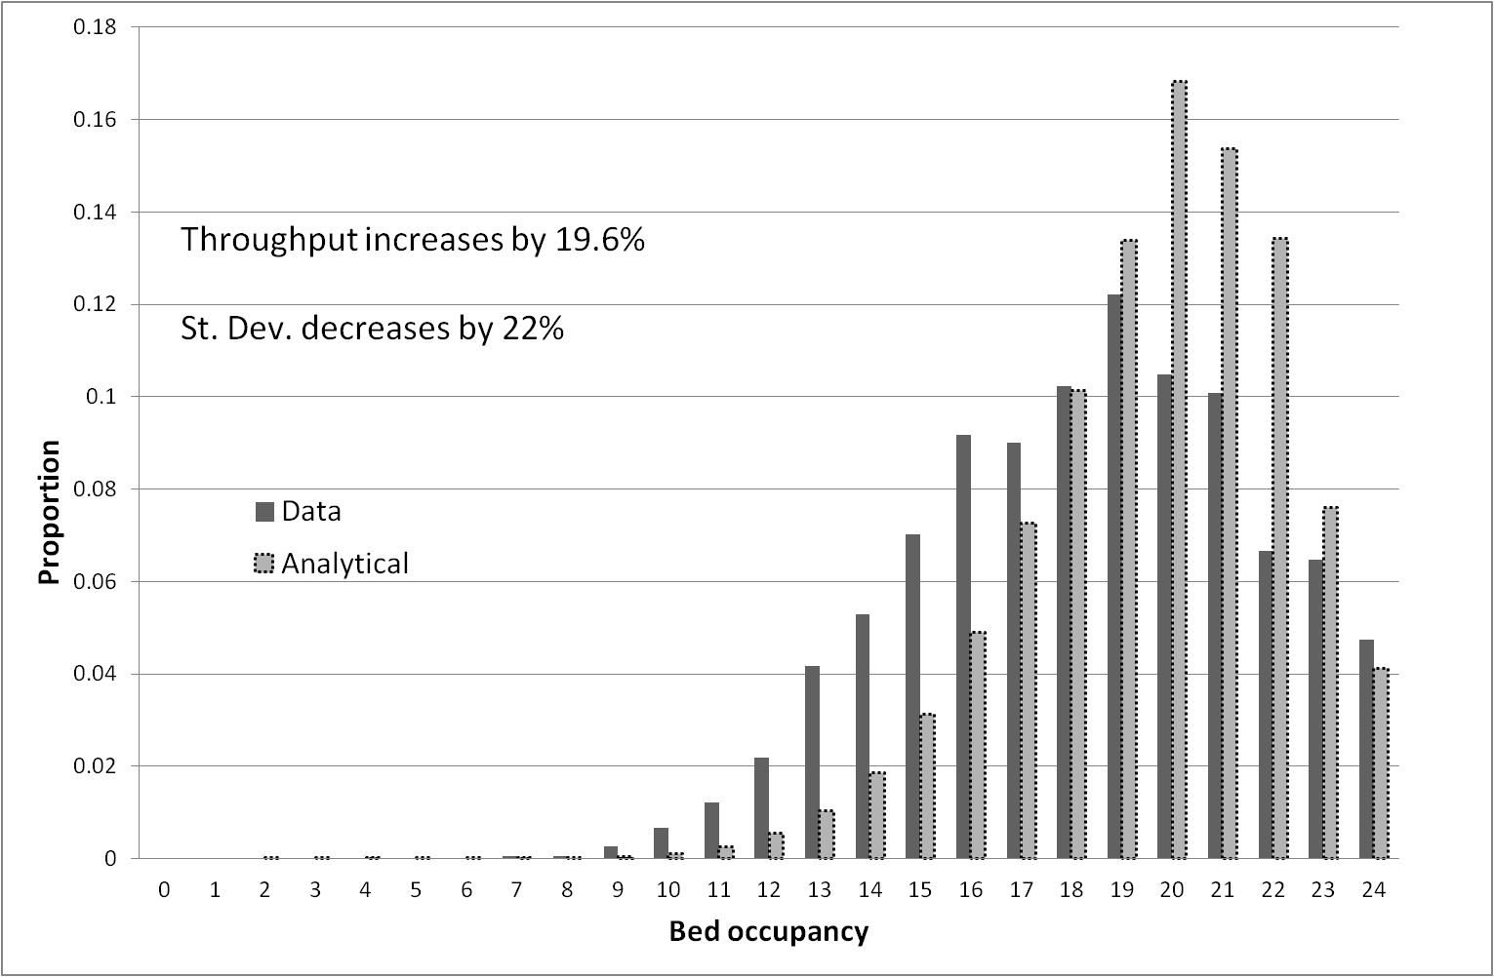

Figure 7 Reduction in variability and increase in throughput by increasing rate of elective patient admissions by 2 per day

If we take a further step by increasing admissions of elective patients by 4 per day at non-busy times, then the corresponding reduction in standard deviation is 38% (2.03), and the increase in throughput is 38% (1855).

A number of questions arise regarding the feasibility of these scenarios in practice.

1. Is it possible to predict the number of beds that will be occupied in *n* days time, given the bed occupancy today?

Using historical data for bed occupancy, it is possible to produce expected levels of bed occupancy on a ‘later day’ basis, but of course the answer to this question depends on the ‘day of the week’ today. As an example, Table 3 provides distributions of ‘most-probable’ bed occupancy levels for ‘two days ahead’ for each day of the week, assuming that 22 beds are occupied on the current day. Further tables were made available covering all combinations of days-of-the week and days ahead. Of greater importance, we are able to provide the director of CCU with further information to aid decision making. We can attach the most probable split between the numbers of emergency and elective patients at future days. Table 4 illustrates an example, where 22 beds are occupied on the current day with different splits between emergency and electives, together with the estimate of the most probable split in future days. This result may be obtained from use of historical data.

|  |  |  |  |  |  |  |  |  |  |
| --- | --- | --- | --- | --- | --- | --- | --- | --- | --- |
|  | **Bed occupancy probabilities 2 days hence from given weekday** | | | | | | | | |
|  | **16** | **17** | **18** | **19** | **20** | **21** | **22** | **23** | **24** |
| **Monday** | 0.136 | 0.136 | 0.091 | 0 | 0.136 | 0.182 | 0 | 0.136 | 0.091 |
| **Tuesday** | 0 | 0.056 | 0.056 | 0.222 | 0.111 | 0.056 | 0 | 0.222 | 0.111 |
| **Wednesday** | 0 | 0.182 | 0.182 | 0 | 0.182 | 0.091 | 0 | 0 | 0.091 |
| **Thursday** | 0.05 | 0 | 0.1 | 0.1 | 0.19 | 0.1 | 0.05 | 0.14 | 0.1 |
| **Friday** | 0 | 0.087 | 0.13 | 0.174 | 0.217 | 0.13 | 0.087 | 0.043 | 0.043 |
| **Saturday** | 0 | 0.053 | 0.158 | 0.105 | 0.158 | 0.158 | 0.263 | 0 | 0 |
| **Sunday** | 0.059 | 0.059 | 0.176 | 0 | 0.176 | 0.059 | 0.059 | 0.176 | 0 |

Table 3 Distribution of number of beds occupied 2 days hence given 22 beds occupied today by day of week, with most probable highlighted.

|  |  |  |
| --- | --- | --- |
| Emergency/Elective split today (BedOcc=22) | Most probable Emergencies  2 days hence | Most probable Electives  2 days hence |
| 12/10 | 11 | 8 |
| 14/8 | 17,18 | 5,7 |
| 15/7 | 14,15 | 5 |
| 16/6 | 17 | 3,4 |
| 17/5 | 17 | 3 |
| 18/4 | 16,17 | 2 |
| 19/3 | 19 | 4 |
| 20/2 | 15,16,17,18,20 | 2 |
| 21/1 | 20 | 1 |
| 22/0 | 14,15 | 3 |

Table 4 Split between emergency and elective beds occupied two days hence, given 22 beds occupied today

1. Is it realistic to expect patients facing elective surgery to have that surgery brought forward at short notice (typically two days)?

Discussions with clinical staff indicate that this indeed may be possible. For example, transplant patients are aware that they may be called for surgery at very short notice if a donated organ becomes available. Likewise, it may be possible to set up a pool of patients waiting for more general surgery, with agreement reached beforehand with patients that their surgery may be performed sooner if they agree to join the pool for call-up at two-days or so notice.

1. Will there be operating theatre availability to accommodate elective patient surgery brought forward at fairly short notice?

Although the answer to this question is rather outside the remit of this study, as it involves hospital departments distinct from the CCU, it should be possible to re-scheduling surgical operations, which are unlikely to require CCU facilities, in order to accommodate patients who probably will require CCU care.

**5. Time-Dependent Aspects**

It was noted in Section 2 that admissions of patients undergoing elective surgery were dependent on the day of the week, with very few patients admitted on weekends. We now adapt the mathematical model to take this factor into account.

We may solve the differential-difference equations given in Table 1 using Euler’s method, Ascher *et al* (1998). A step-length (hours) was used, and the process was run to produce bed occupancy levels for 168 hours (hours in a week). The appropriate values of and for , using Equation (3), were used for the first 120 hours of the week (ie. Monday to Friday), and then the reduced value for (and the associated value of ) were used over the period 120 – 168 hours (Saturday and Sunday). The computation time for this process was just a few seconds.

Figure 8 illustrates how the mean bed occupancy and the standard deviation vary over the week, and Figure 9 shows how selected probabilities vary. It should be noted that the mean bed occupancy, the standard deviation, and the individual probabilities have identical values at the beginning and end of each week; that is, the model works on a weekly cycle. As expected, over the weekend (120 – 168 hours), the probabilities of lower levels of bed occupancy increase (eg. $P_{12}$ and $P_{16}$), and the probabilities of higher levels decrease (eg. $P_{20}$ and $P_{24}$). The quantitative information contained therein is obviously of importance to the CCU director in informing his decision making regarding bed management over the seven day cycle.

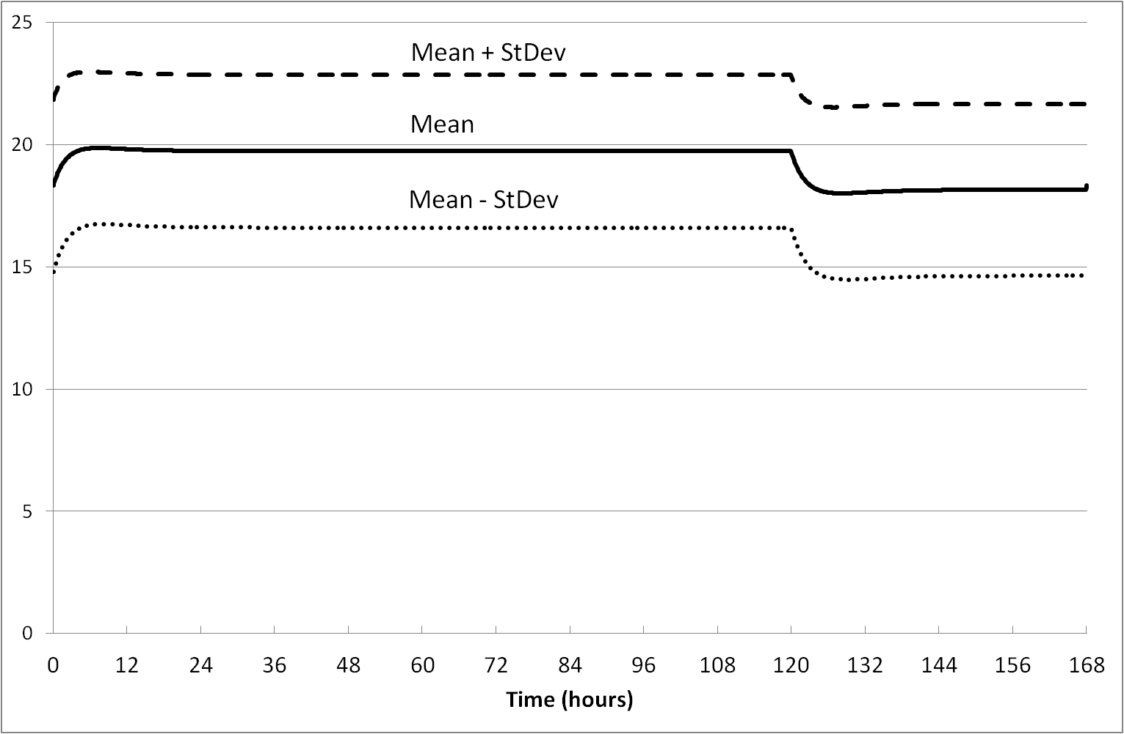

Figure 8 Variation in bed occupancy over the week

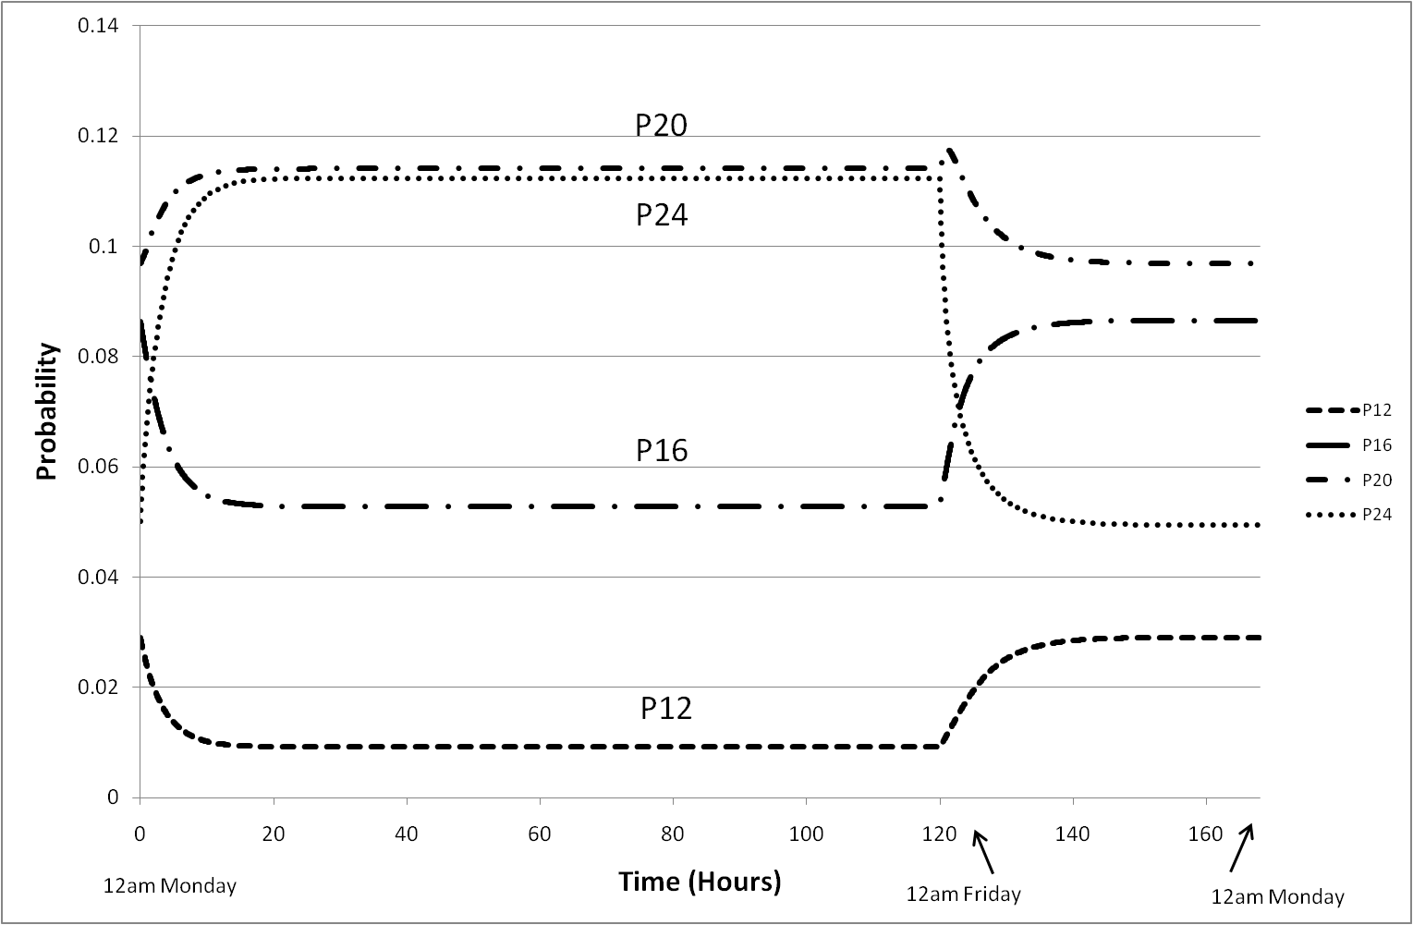

Figure 9 Probabilities of beds occupied over a week

**6. Nursing Levels**

The largest proportion of the operating cost in a CCU is the nursing cost. In Section 1 it was stated that some patients require a 1:1 nurse:patient ratio, whilst the less seriously ill require a 1:2 ratio. The director of the CCU is faced with the difficult decision as to how many nurses to employ per shift. If too many nurses are employed, then there is potential for large wastage in nursing cost. If too few nurses are employed, then serious consequences could arise in terms of patient care, unless the shortfall is made up by employing agency nurses. However, agency nurses cost three times as much as the hospital’s own nurses. There are also problems of a domestic nature. As a general rule, hospital-employed nurses need to know their shift rotas significantly well into the future. The current practice is that nurses are employed on 13-hour shifts (this allows for a 1-hour overlap with incoming nurses at the shift changeover). We now propose a simple cost model to optimise the number of nurses to be employed per shift.

We denote the cost of employing a hospital-based nurse per shift by , and the cost of employing an agency-based nurse by  Let be the number of hospital nurses employed per shift. Suppose at any particular time there are  beds occupied, and that the nurse:patient ratio required is 1:1 for all patients. Then the total nursing cost, , may be represented by

 (4)

We are able to evaluate the probabilities of beds being occupied from Eqn (2), and hence we may determine the expected nursing costs for appropriate values of *q*.

Table 5 shows some results for specified values of , using *k*=3. As may be seen, it appears that the optimal number of hospital-based nurses that should be employed per shift is 20, as the cost is the lowest for *q*=20.

|  |  |
| --- | --- |
| Number of hospital-employed nurses | Cost |
| 17 | 23.34 |
| 18 | 22.52 |
| 19 | 22.00 |
| 20 | 21.85 |
| 21 | 22.01 |
| 22 | 22.48 |
| 23 | 23.14 |

Table 5 Nursing cost for appropriate number of hospital employed nurses.

We now look at this problem in a little more detail. When a patient is admitted, a decision is made on the basis of the information available as to the level of care required – level 3 requires a 1:1 ratio, while levels 1 and 2 require 1:2. However, patients’ conditions may deteriorate or improve during their stay in CCU, and hence their level of nursing care may also change. A reasonable proxy is to assume that elective patients require Level 1 or 2 care, and emergency patients require Level 3 care. We thus need to use the probabilities as determined by Eqn (1). The number of nurses required is then given by . The expression for the probability that nurses will be required on a particular shift needs careful consideration. The number of required nurses is given by:



Thus for given and  we have:



Thus the probability that we need exactly nurses is given by:



and so the Cumulative Distribution Function (CDF) for the nurse demand is given by:

 (5)

Table 6 gives an estimate (which should be more appropriate) of the number of hospital-based nurses that should be employed per shift.

|  |  |
| --- | --- |
| Number of hospital-employed nurses | Cost |
| 16 | 21.53 |
| 17 | 20.81 |
| 18 | 20.43 |
| 19 | 20.41 |
| 20 | 20.72 |
| 21 | 21.30 |
| 22 | 22.08 |

Table 6 Expected cost of hospital-employed nurses, assuming 1:1 nurse: patient ratio for emergency patients, and 1:2 ratio for elective patients.

It is worth noting that this problem of nurse staffing can also be approach using a stochastic model from inventory theory. Indeed, the newsboy model (Winston 1998) models a stock control problem to which is associated an undersupply cost  and an oversupply cost . It can be shown that the optimal stock  level satisfies:



whereis the cumulative distribution function (CDF) of the stochastic demand. We can model a nurse staffing problem with  and . In our case  and is given by (5). Table 7 shows the CDF and we see that the newsboy model approach to this problem also recommends 19 nurses.

|  |  |
| --- | --- |
|  |  |
| 16 | 0.4245 |
| 17 | 0.5402 |
| 18 | 0.6605 |
| 19 | 0.7695 |
| 20 | 0.8594 |
| 21 | 0.9283 |
| 22 | 0.9759 |

Table 7 Cumulative Distribution Function representing the demand for nurses.

The difference in these two approaches is that the first optimises an actual expected cost whereas the newsboy model optimises the expected wastage costs.

**7. Conclusions**

The objective of this paper has been to show how a mathematical modelling approach is able to provide quantitative evidence to aid decision making in an environment which is beset with uncertainty. Incorrect decisions in a Critical Care Unit are likely to have far-reaching consequences. Although this study has used information and data from a particular CCU in a large teaching hospital, the authors are confident that the modelling described herein is of a generic nature, and hence could be applied with little amendment in other hospitals.

The paper has addressed the problem of decreasing the variability in the number of beds occupied on any particular day by recommending that advantage is taken when bed occupancy is low by allowing a small increase in planned (elective) admissions. The result of this is to alter the distribution of beds occupied quite significantly, as shown in comparing Figures 6 and 7. This strategy also increases the throughput of patients by a considerable degree, and some ideas are provided as to the feasibility in practice of achieving this suggestion (Section 4).

Using historical data, it is possible to estimate the most probable level of bed-occupancy for several days in advance, given the bed occupancy on the current day. In addition, the model is able to predict the expected split between emergency and elective patients over the forthcoming days (Table 4).

Finally, and probably most importantly from a cost point-of-view, the problem of how many nurses the hospital should employ for each shift has been addressed. The model has been used to consider the balance between the numbers of hospital-employed nurses and the numbers of agency-employed nurses which should be utilised in order to minimise the overall nursing costs (Tables 5, 6, 7).

At the time of writing these matters are under discussion with hospital managers.

**References**

1. Ascher, Uri M.; Petzold, Linda Ruth. Computer methods for ordinary differential equations and differential-algebraic equations. 1998. [SIAM](http://en.wikipedia.org/wiki/SIAM). Philadelphia
2. Au, L., Byrnes, G., Bain, C., Fackrell, M., Brand, C., Campbell, D., & Taylor, P. (2009). Predicting overflow in an emergency department. *IMA Journal of Management Mathematics*, *20*(1), 39. IMA.
3. Bailey NTJ. 1952. A study of queues and appointment systems in hospital out-patient departments, with special reference to waiting-times. *Journal of the Royal Statistical Society. Series B (Methodological)*. 14(2):185–199.
4. Cahill W, Render M. 1999. Dynamic simulation modeling of ICU bed availability. *Simulation Conference Proceedings.* 1573-1576.
5. Cooper JK, Corcoran TM. 1974. Estimating bed needs by means of queuing theory. *New England Journal of Medicine.* 291(8):404–405.
6. Costa X, Ridley SA, Shahani AK, et al. 2003. Mathematical modelling and simulation for planning critical care capacity. *Anaesthesia*. 58(4):320-7.
7. Creemers S, Lambrecht M. 2008. Healthcare queueing models. *Leuven Faculty of Business and Economics Report.*
8. Erlang AK. 1909. The theory of probabilities and telephone conversations. *Nyt Tidsskrift for Matematik B*; 20:33.
9. Fackrell M. 2009. Modelling healthcare systems with phase-type distributions. *Health Care Management Science.* 12(1):11-26.
10. Fomundam S, Herrmann JW. 2007. A survey of queuing theory applications in healthcare. *Mechanical Engineering*.
11. Gorunescu F, McClean SI, Millard PH. 2002. A queueing model for bed-occupancy management and planning of hospitals. *Journal of the Operational Research Society.* 53(1):19–24.
12. Green LV, Kolesar PJ, Soares J. 2001. Improving the Sipp Approach for Staffing Service Systems That Have Cyclic Demands. *Operations Research*, *49*(4), 549-564.
13. Green L, Kolesar P, Svoronos A. 1991. Some Effects of Nonstationarity on Multiserver Markovian Queueing Systems. *Operations Research*.
14. Green LV, Soares J, Giglio JF, Green RA. 2006. Using queueing theory to increase the effectiveness of emergency department provider staffing. *Academic emergency medicine: official journal of the Society for Academic Emergency Medicine*, *13*(1), 61-8.
15. Griffiths JD, Price-Lloyd N, Smithies M, Williams JE. 2005. Modelling the requirement for supplementary nurses in an intensive care unit. *Journal of the Operational Research Society*. 56(2):126-133.
16. Griffiths JD, Price-Lloyd N. 2005. A queueing model of activities in an intensive care unit. *IMA Journal of Management Mathematics.* 17(3):277-288.
17. Gross D, Harris CM. 1998. Fundamentals of Queuing Theory, third ed., New York: Wiley
18. Harper PR, Shahani a K. 2002. Modelling for the planning and management of bed capacities in hospitals. *Journal of the Operational Research Society*. 53(1):1118.
19. Ingolfsson A, Akhmetshina E, Budge S, Li Y, Wu X. 2007. A Survey and Experimental Comparison of Service-Level-Approximation Methods for Nonstationary M(t)/M/s(t) Queueing Systems with Exhaustive Discipline. *INFORMS Journal on Computing*, *19*(2), 201-214.
20. Jennings OB, Mandelbaum A, Massey WA, Whitt W. 1996. Server staffing to meet time-varying demand. *Management Science*, *42*(10), 1383–1394.
21. Kendall DG. 1953. Stochastic processes occurring in the theory of queues and their analysis by the method of the imbedded Markov chain. *The Annals of Mathematical Statistics.* 54(3):338–354.
22. Kim SC, Horowitz I, Young KK, Buckley TA. 1999. Analysis of capacity management of the intensive care unit in a hospital. *European Journal Of Operational Research.* 115:36-46.
23. Litvak N, Vanrijsbergen M, Boucherie R, Vanhoudenhoven M. 2008. Managing the overflow of intensive care patients. *European Journal of Operational Research*. 185(3):998-1010.
24. Shahani A K, Ridley SA, Nielsen MS. 2008. Modelling patient flows as an aid to decision making for critical care capacities and organisation. *Anaesthesia*. 63(10):1074-80.
25. Winston WL. 1998. Operations Research: Applications and Algorithms. Brooks/Cole.